Experiment 2: Cross-Site Scripting (XSS) using Juice Shop and Burp Suite
Prerequisites:
OWASP Juice Shop is installed and running on http://localhost:3000

Pull the OWASP Juice Shop Docker Image
Open Terminal / Command Prompt and run:
docker pull bkimminich/juice-shop
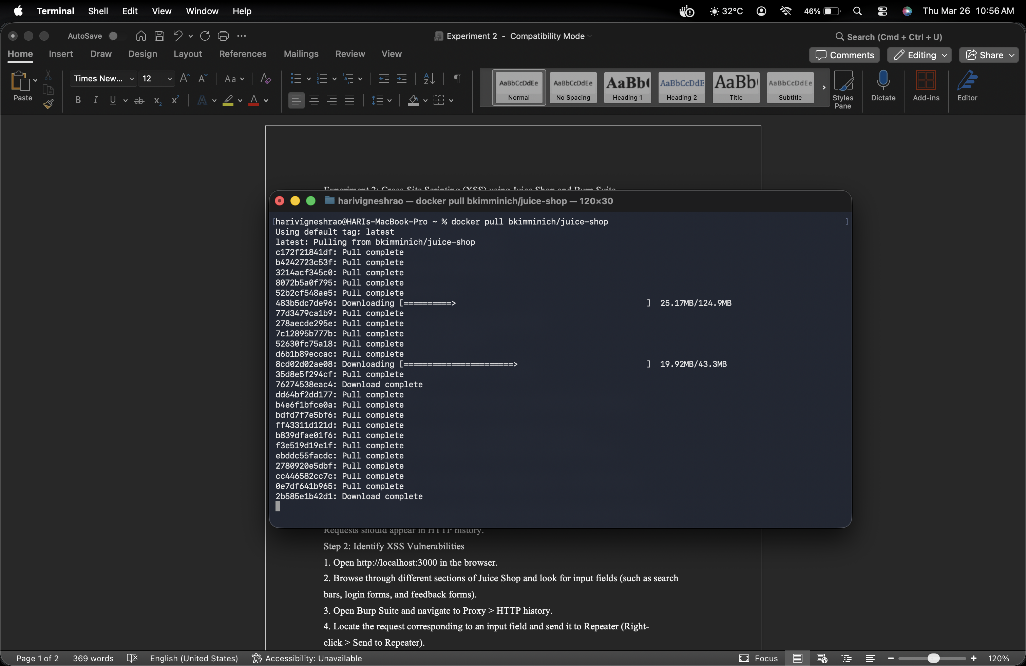

Run the Juice Shop Container
After the image is downloaded, run:
docker run -d -p 3000:3000 bkimminich/juice-shop
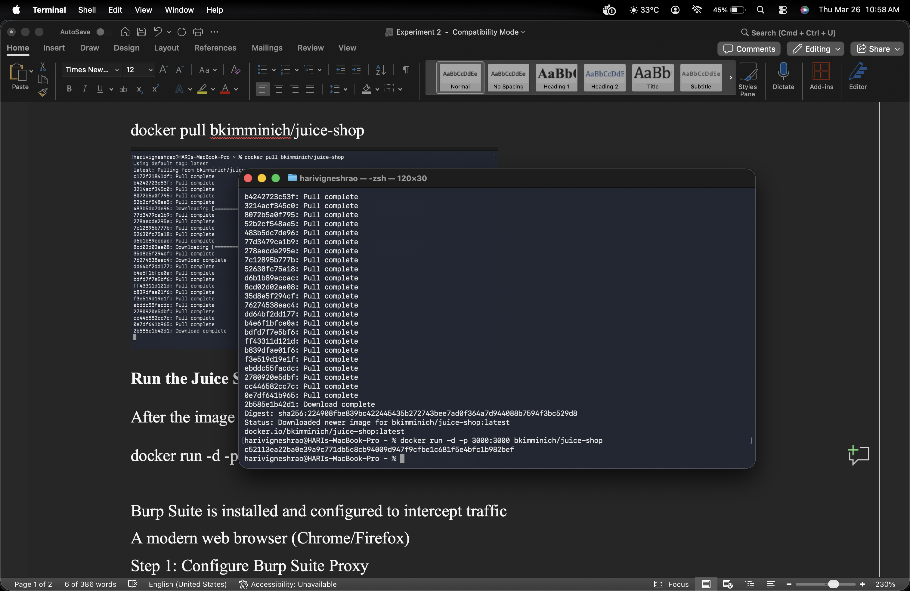

Access OWASP Juice Shop
Open your browser and navigate to:
http://localhost:3000
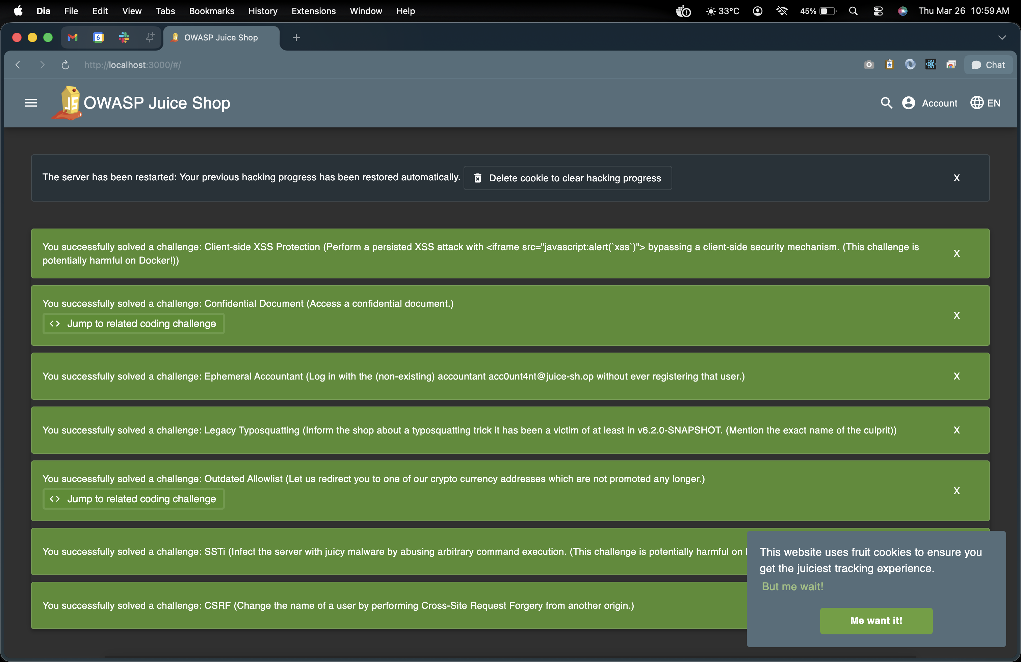
Burp Suite is installed and configured to intercept traffic
A modern web browser (Chrome/Firefox)
Step 1: Configure Burp Suite Proxy
1. Open Burp Suite and navigate to Proxy > Intercept.
2. Ensure Intercept is off.

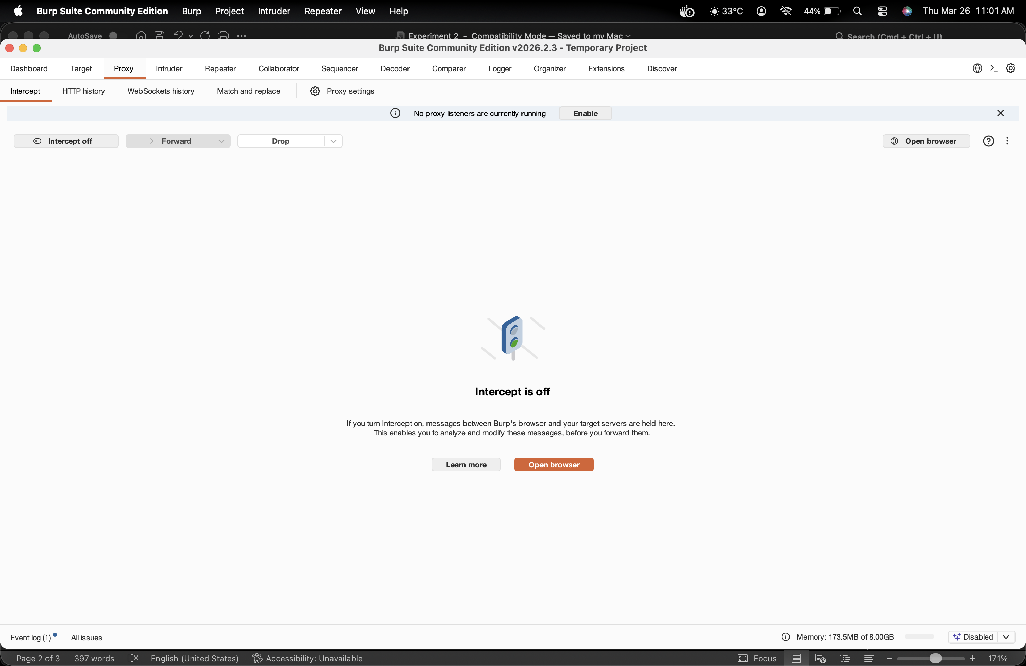
3. Go to Proxy > Options, under Proxy Listeners, check that Burp is listening on
127.0.0.1:8081.
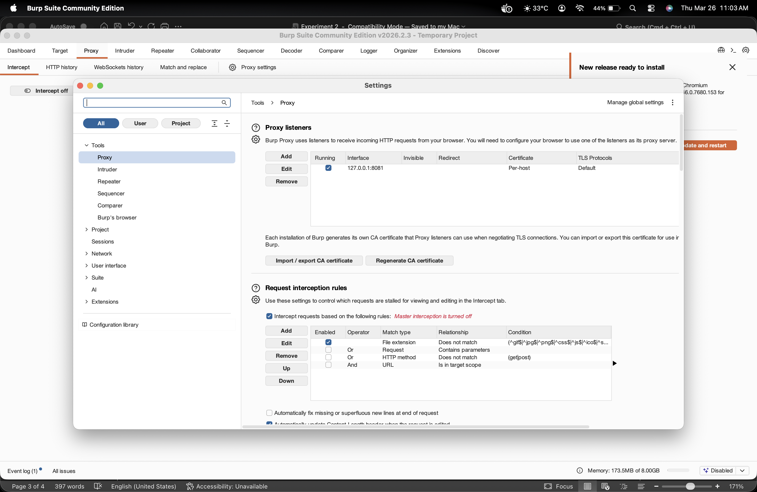

4. Open your browser and configure it to use Burp Suite as a proxy:
O Chrome: Settings > Proxy settings > Manual proxy > Set HTTP Proxy to
127.0.0.1, Port 8081.
O Firefox: Preferences > Network Settings > Manual proxy > Set HTTP Proxy to
127.0.0.1, Port 8081.
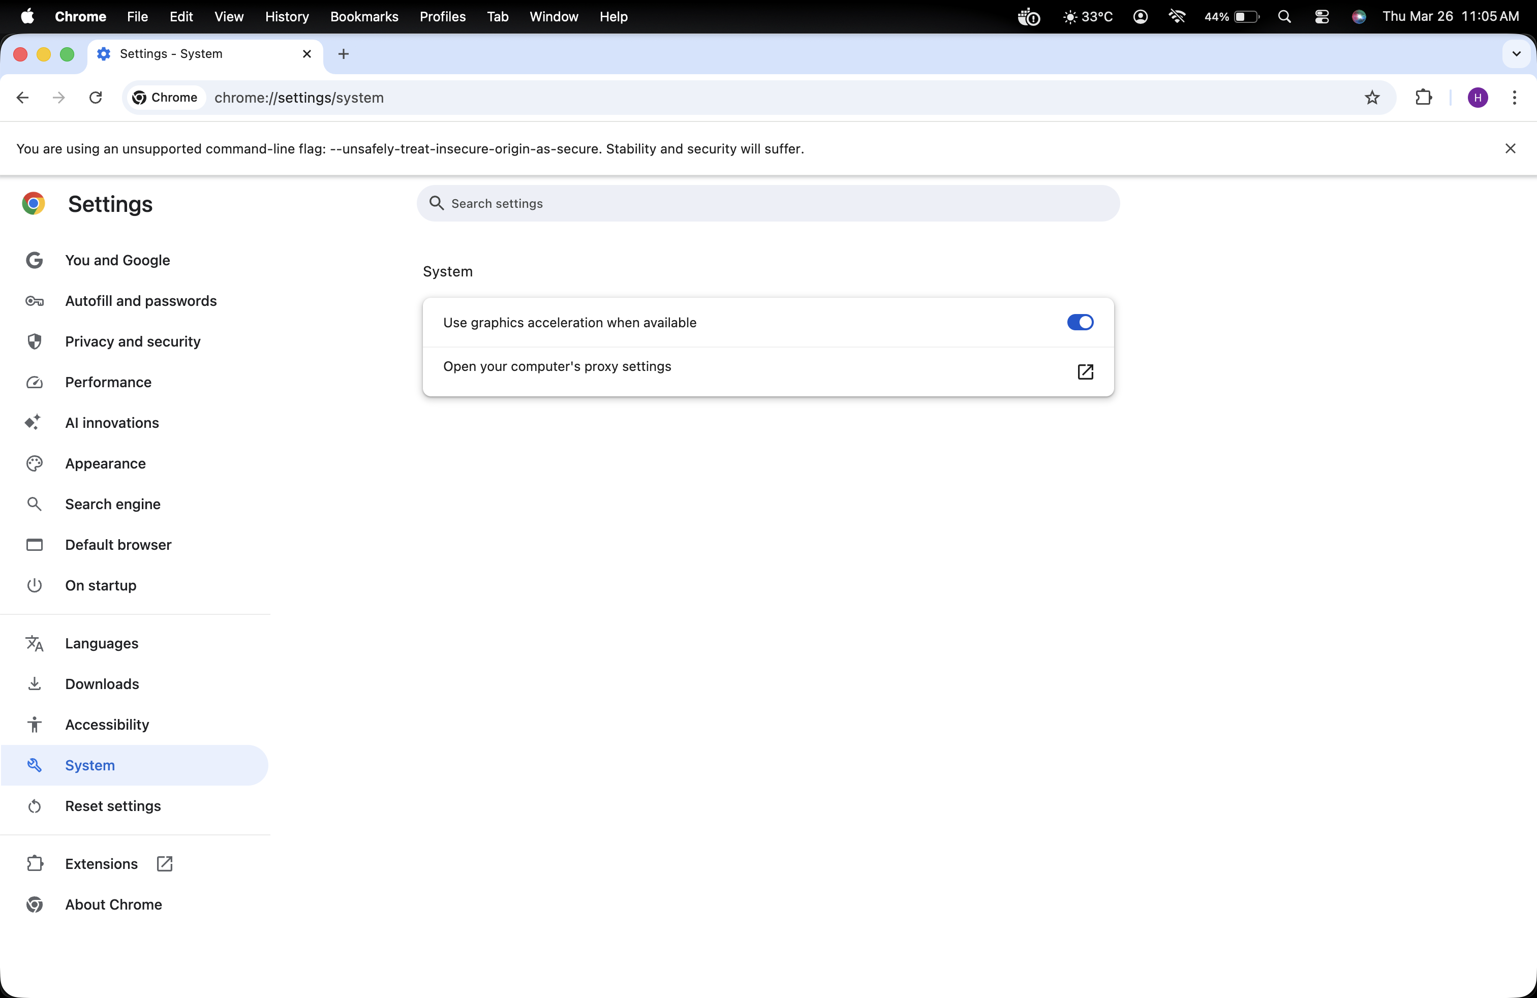

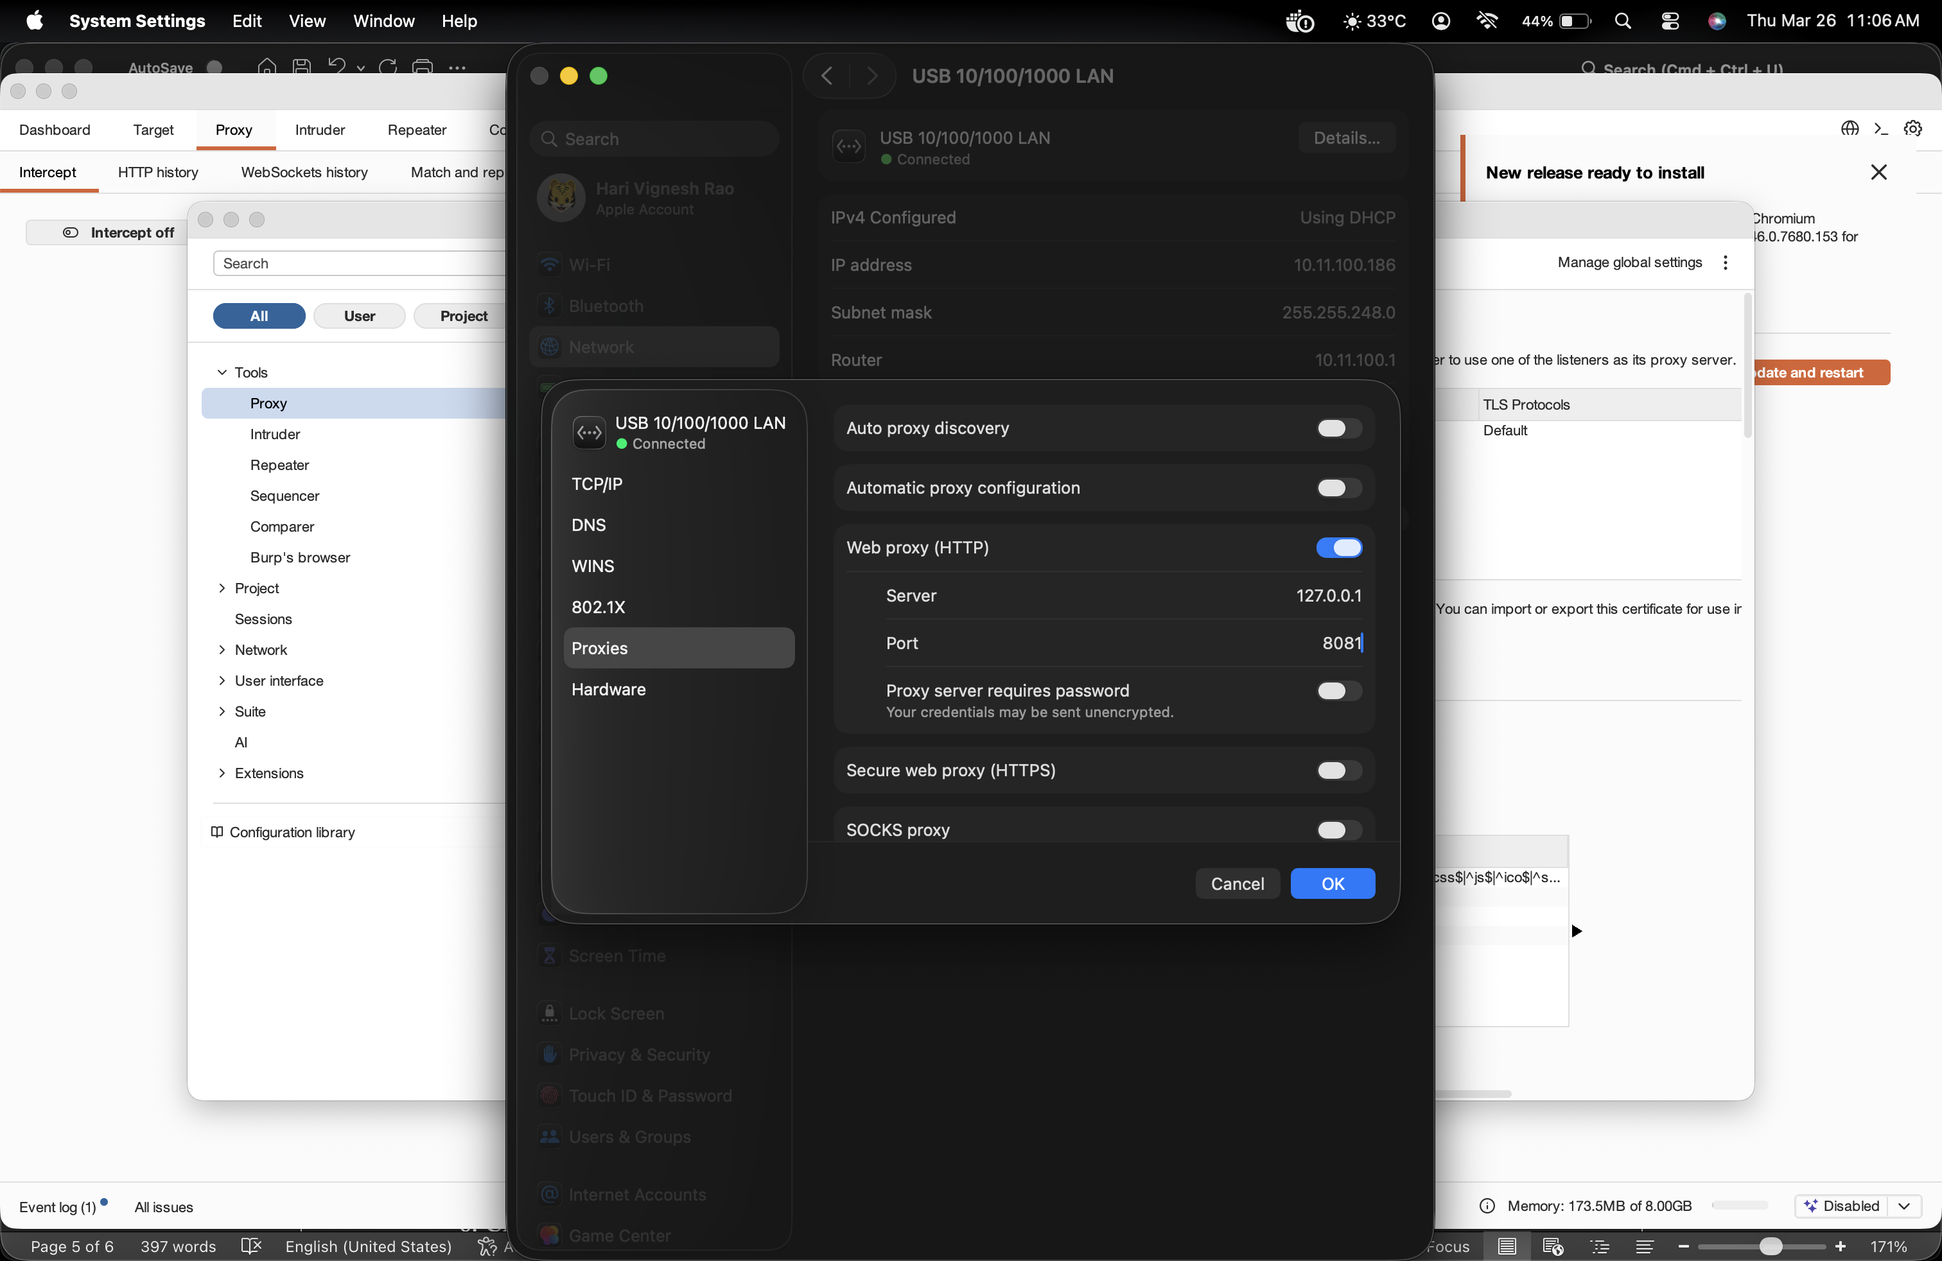
5. Verify by opening http://localhost:3000 in your browser while Burp Suite is running.
Requests should appear in HTTP history.

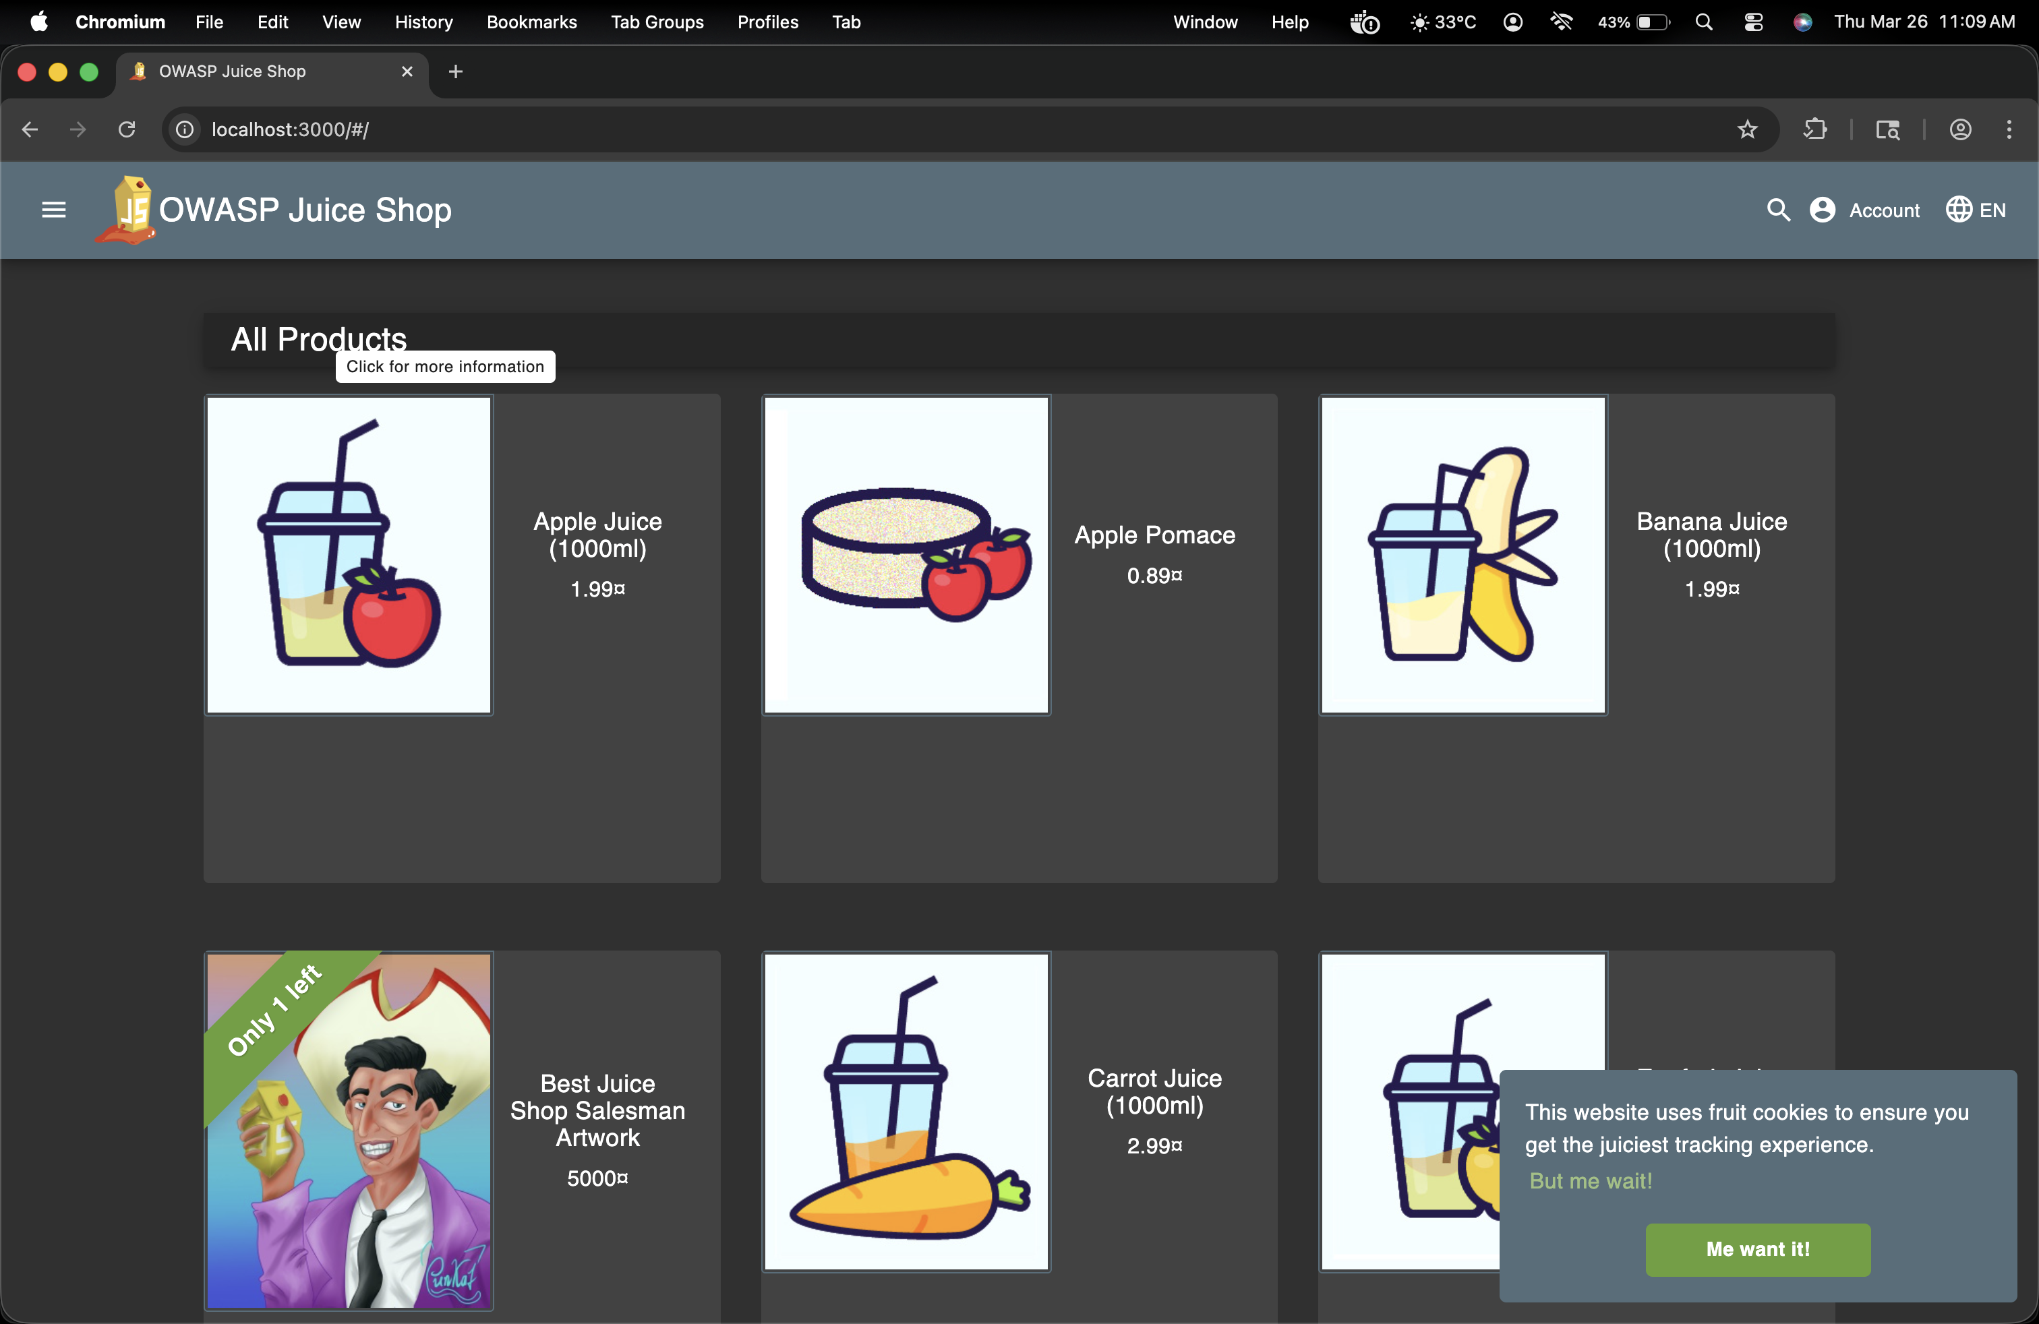
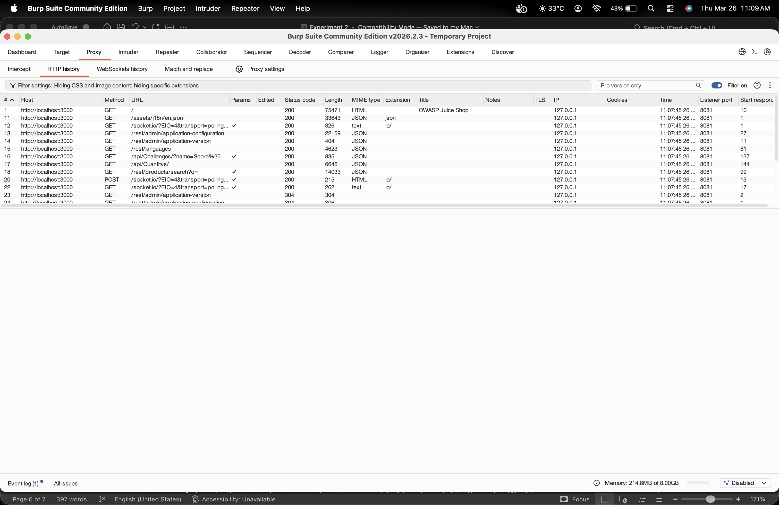
Step 2: Identify XSS Vulnerabilities
- Open http://localhost:3000 in the browser.
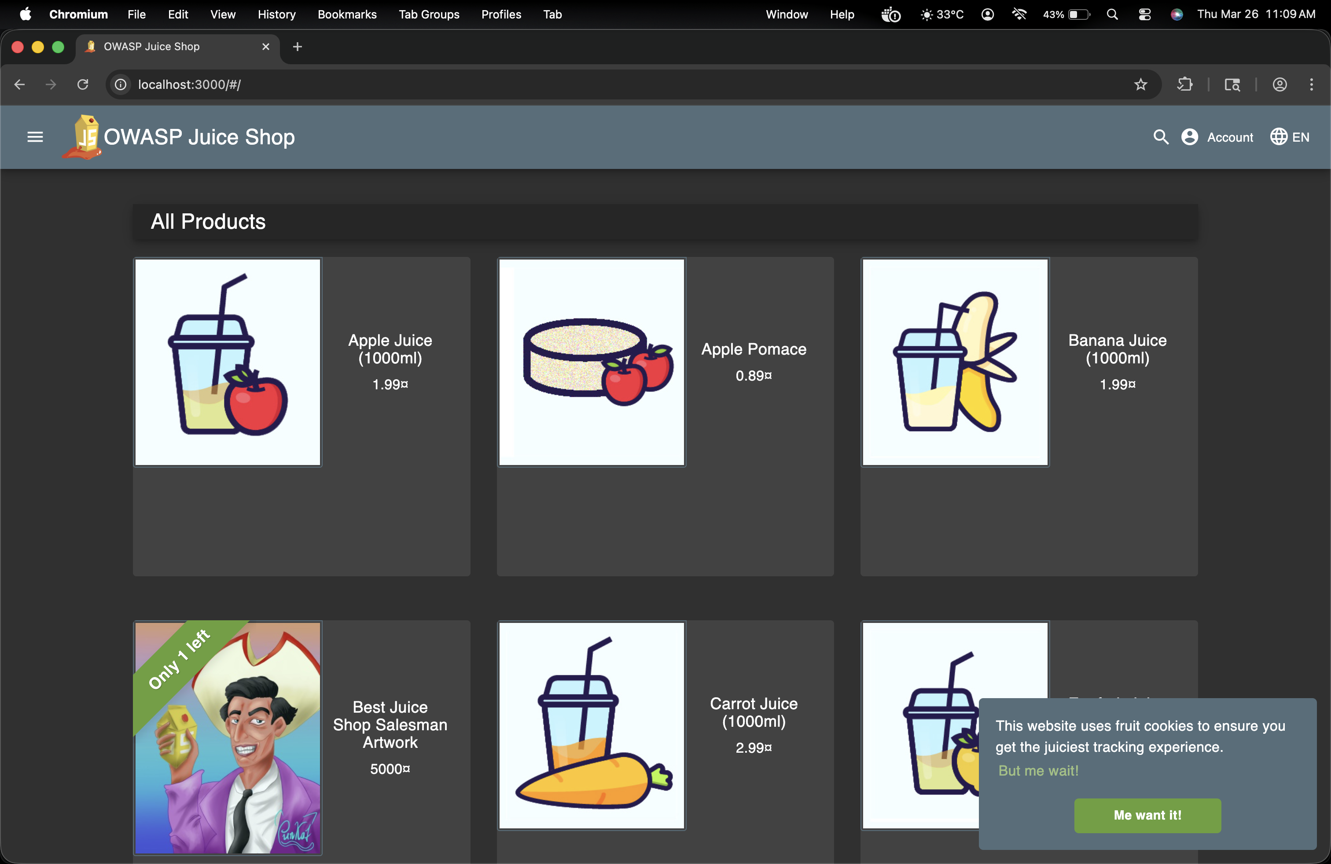

2. Browse through different sections of Juice Shop and look for input fields (such as search
bars, login forms, and feedback forms).

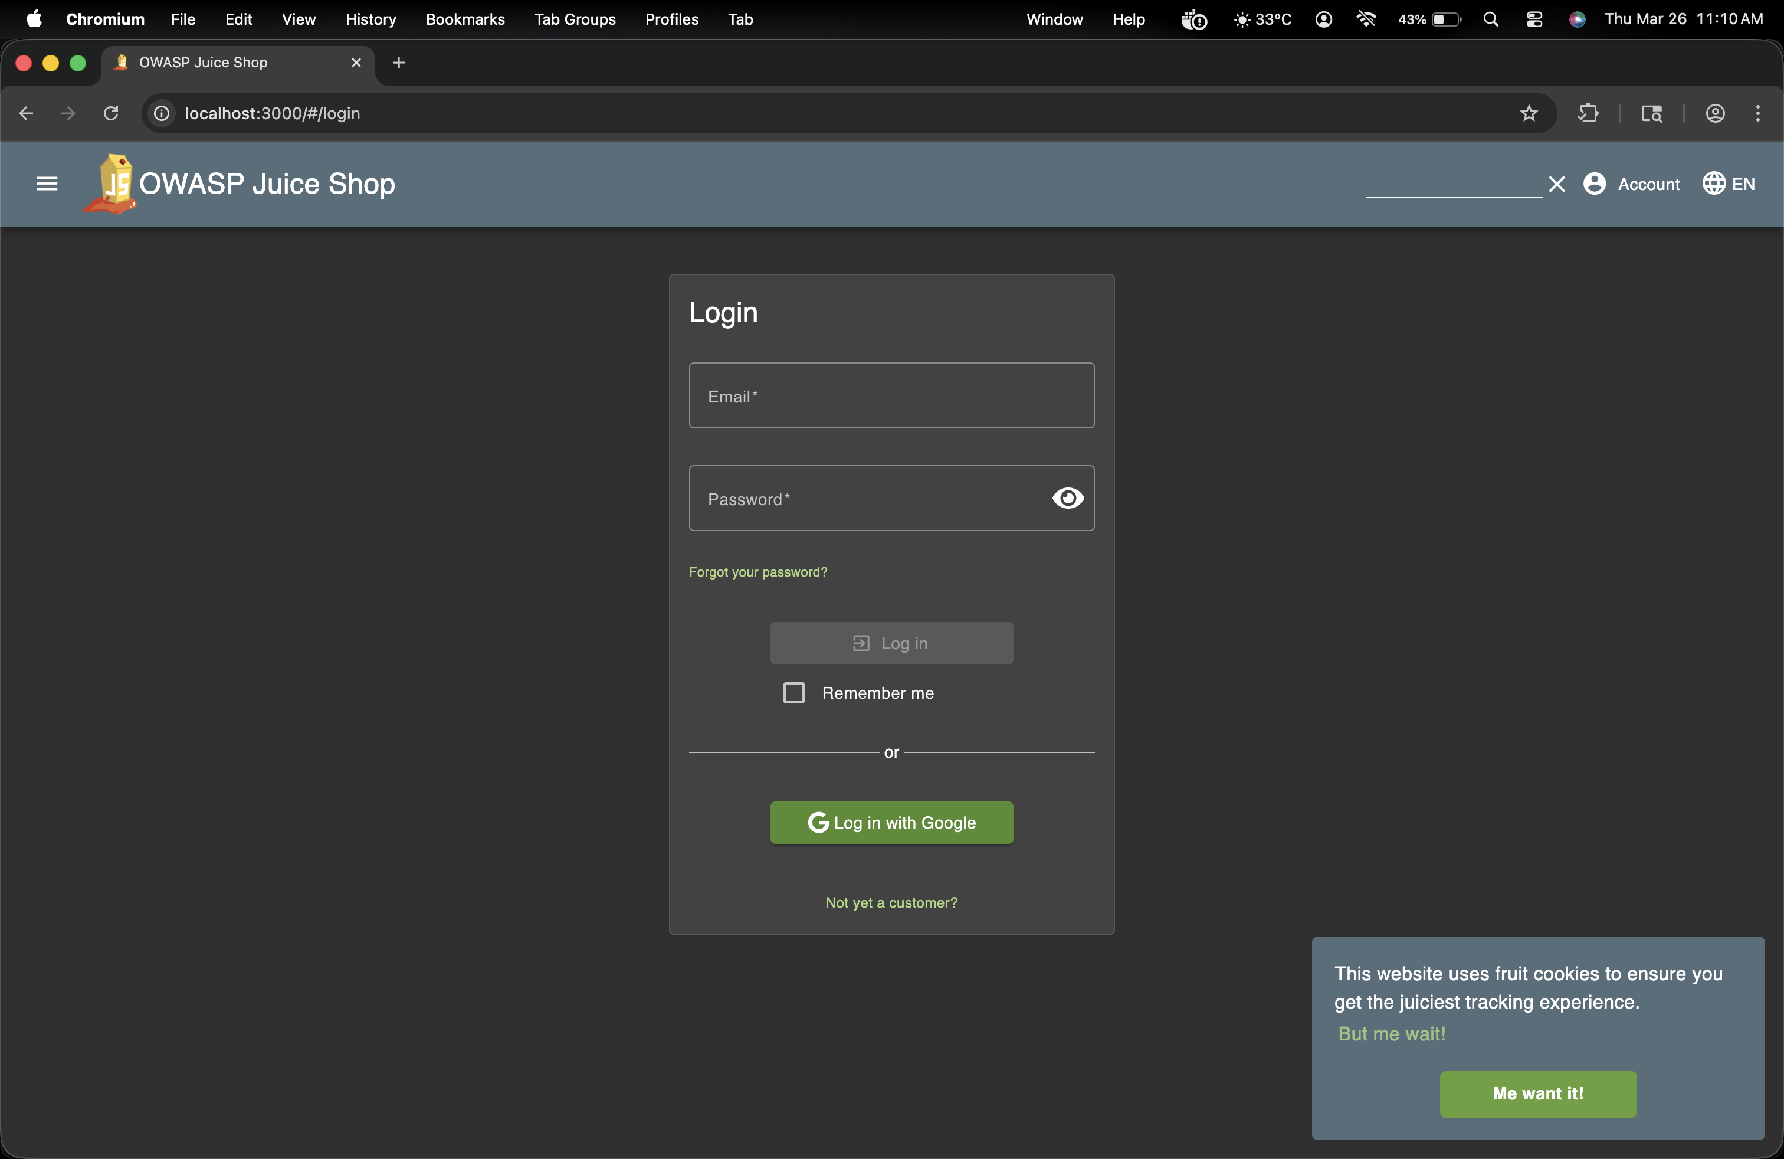
- Open Burp Suite and navigate to Proxy > HTTP history.
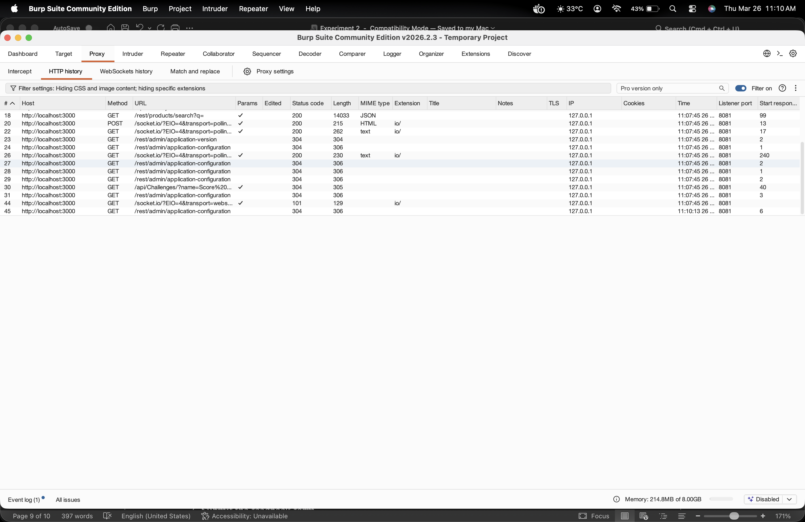
4. Locate the request corresponding to an input field and send it to Repeater (Right-
click > Send to Repeater).
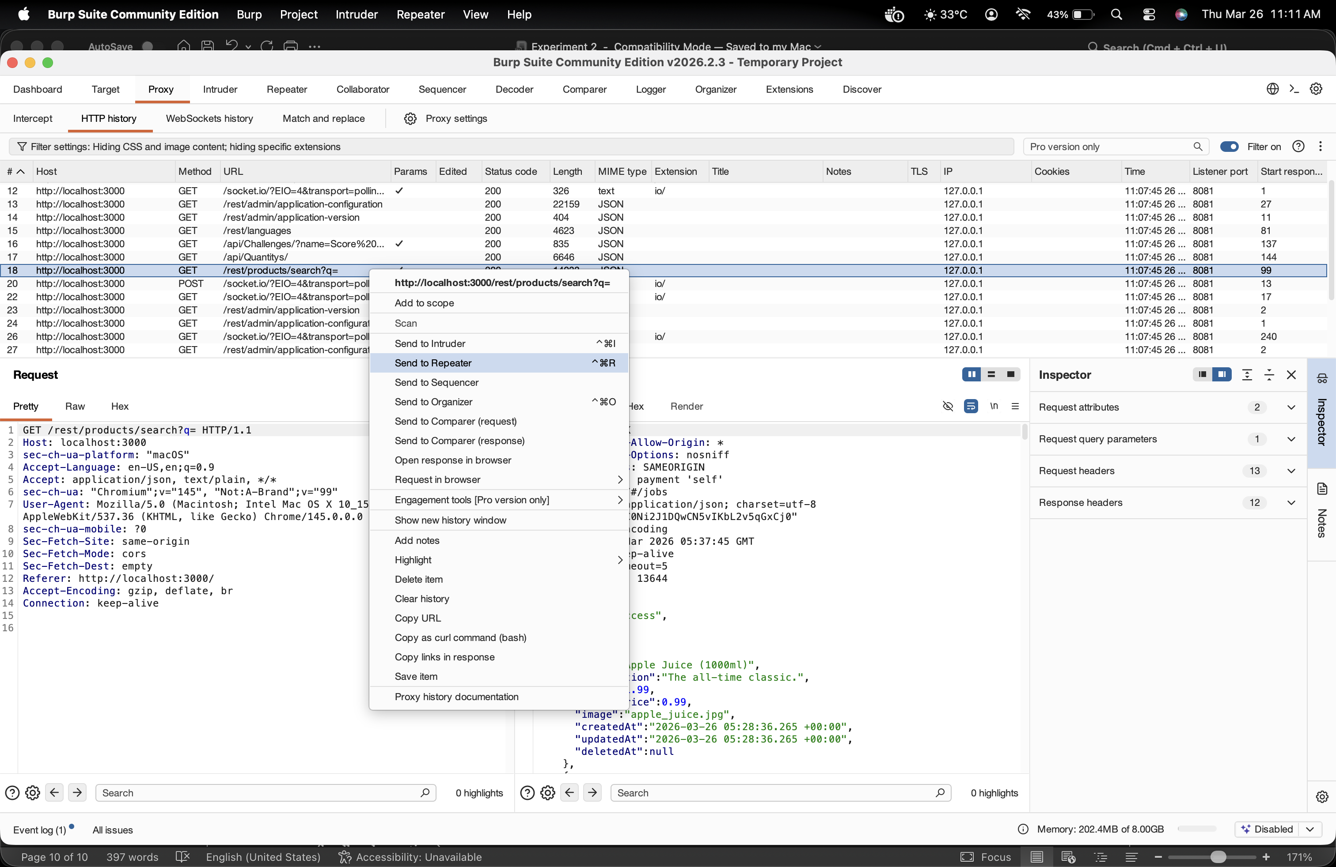
5. In the Repeater tab, experiment by modifying the input fields with JavaScript payloads
such as:
<script>alert("XSS')</script>
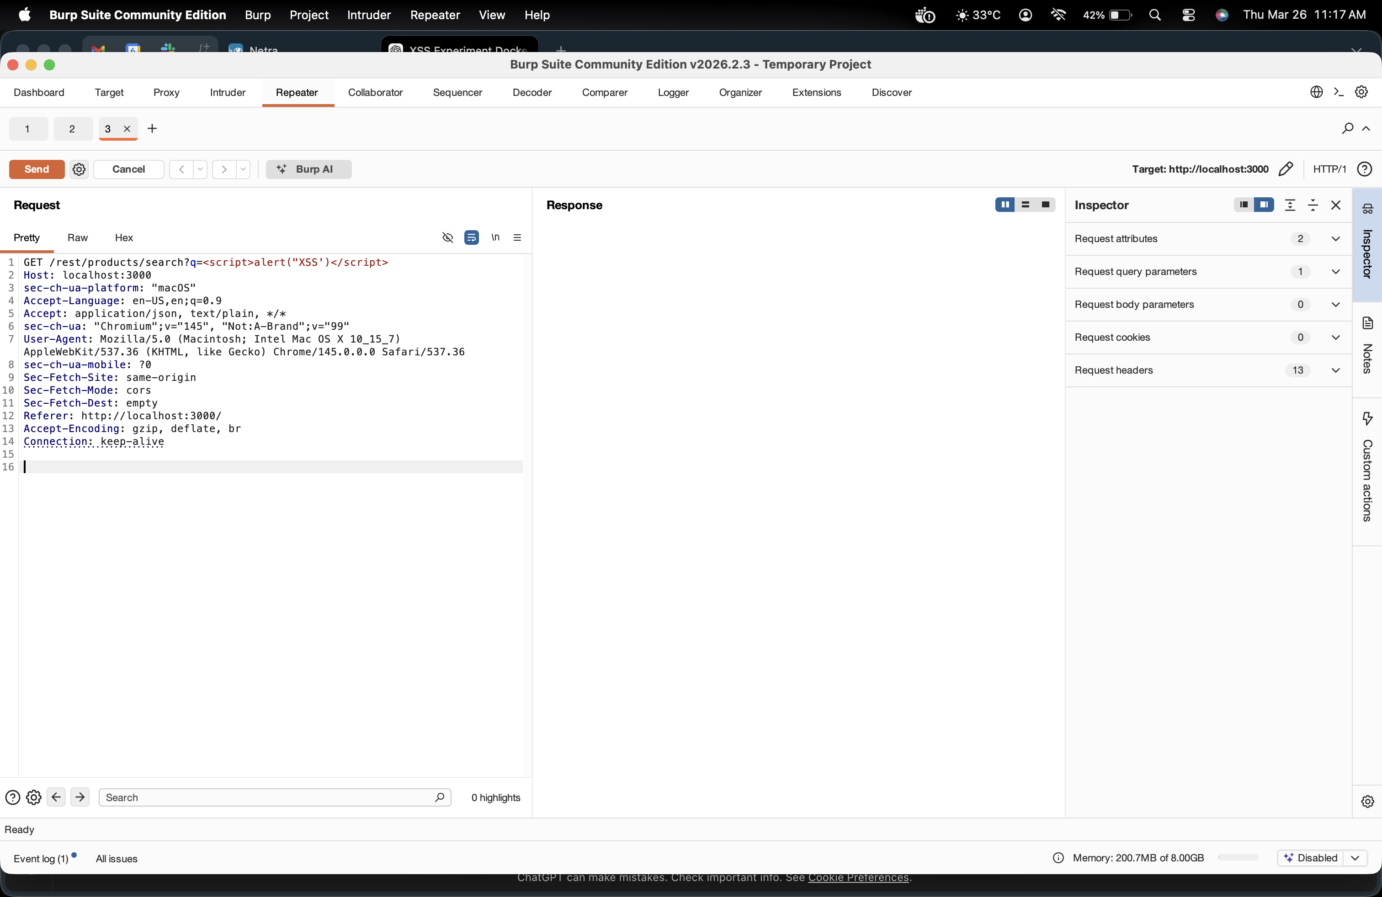
6. Click Send and observe the response for execution of the script.
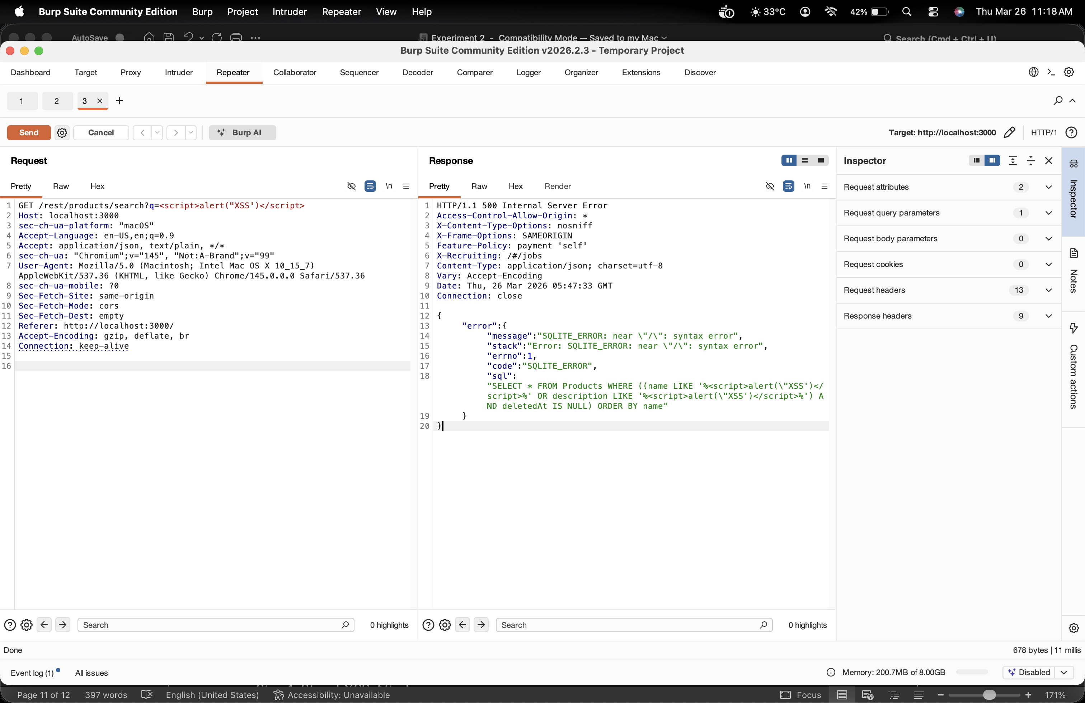
Step 3: Exploiting XSS in Feedback Form
- In Juice Shop, navigate to Contact Us or Feedback page.
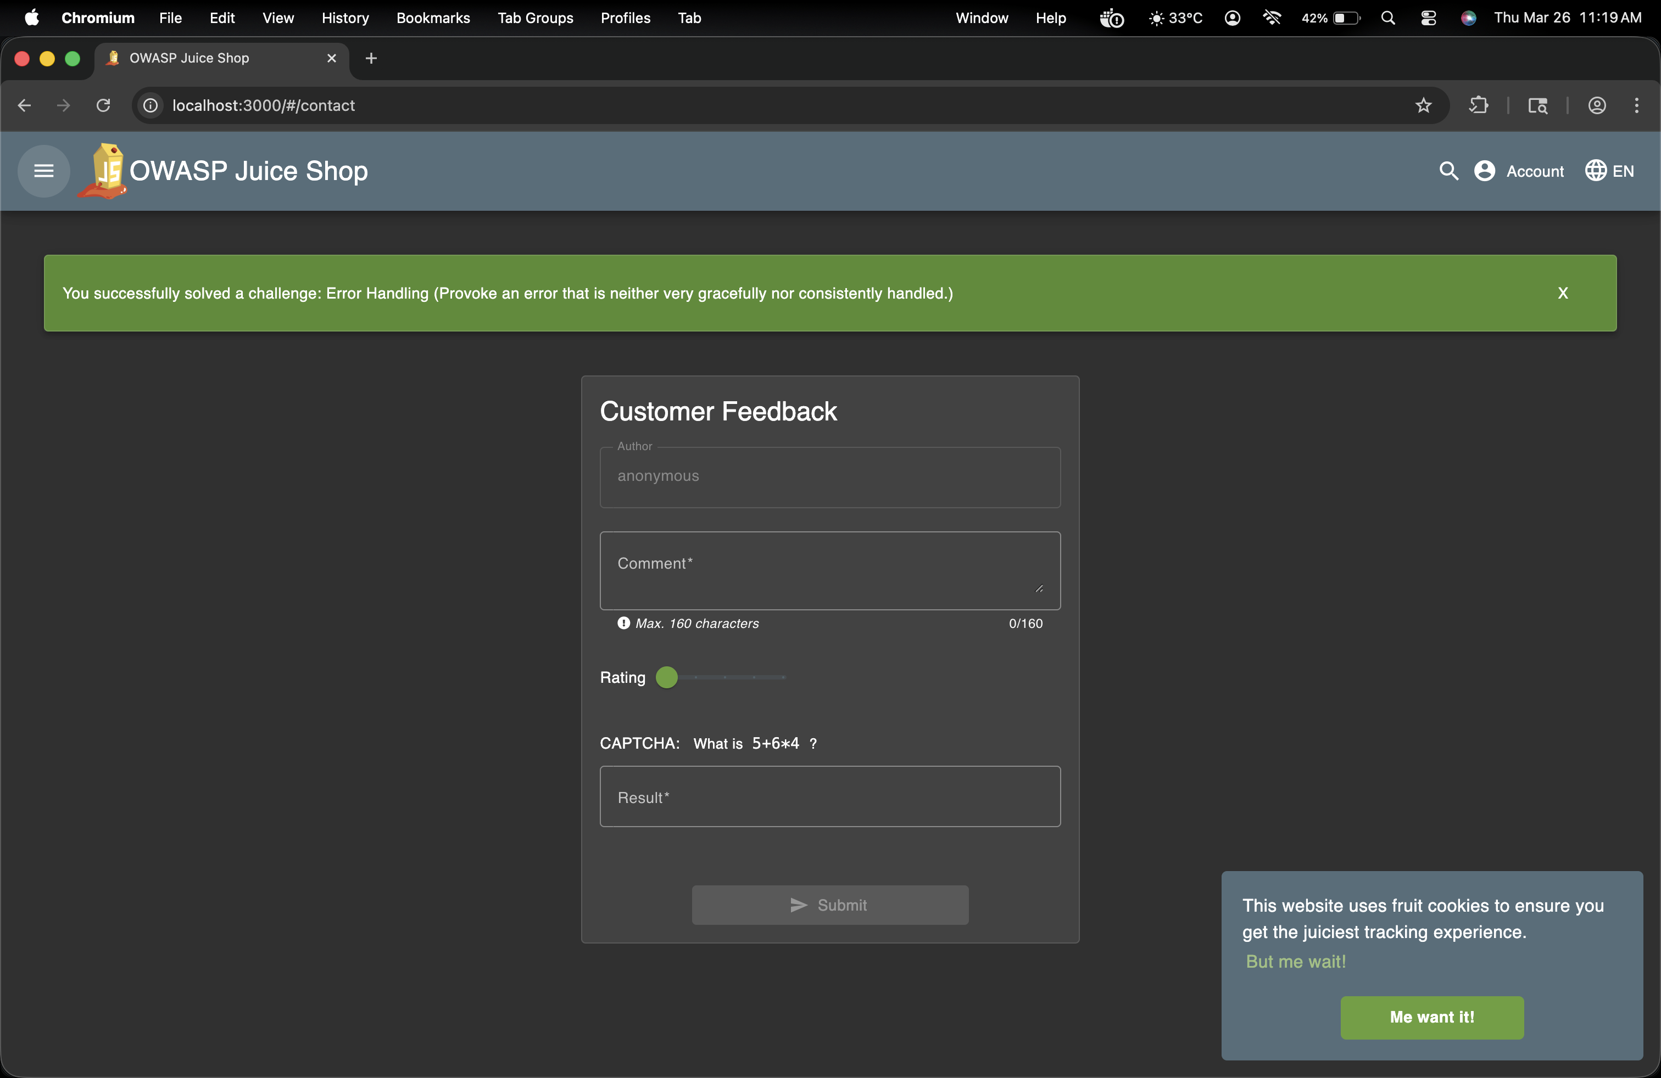
- Enter the following payload in the comment field: <script>alert("XSS')</script>
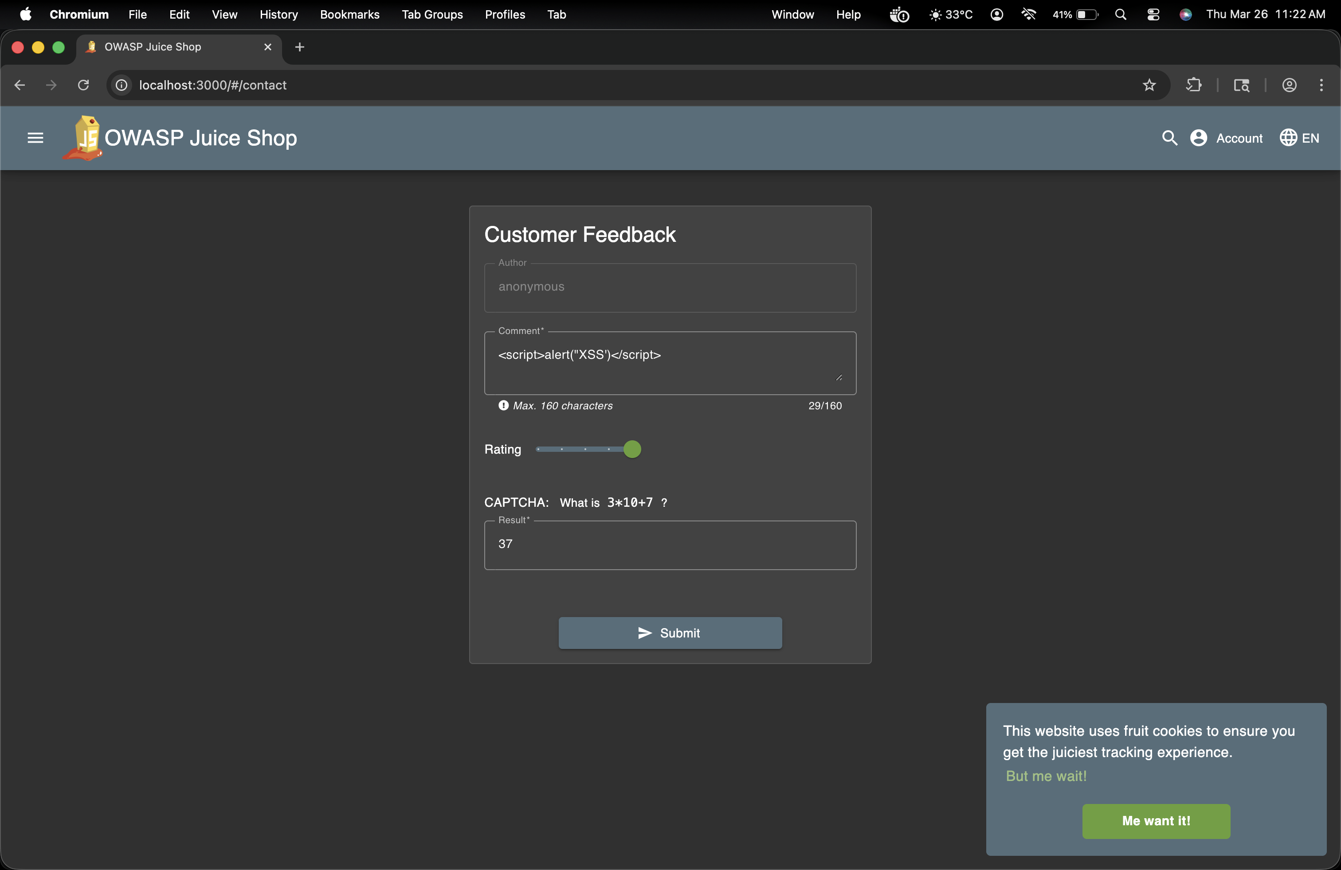
- Submit the feedback form.
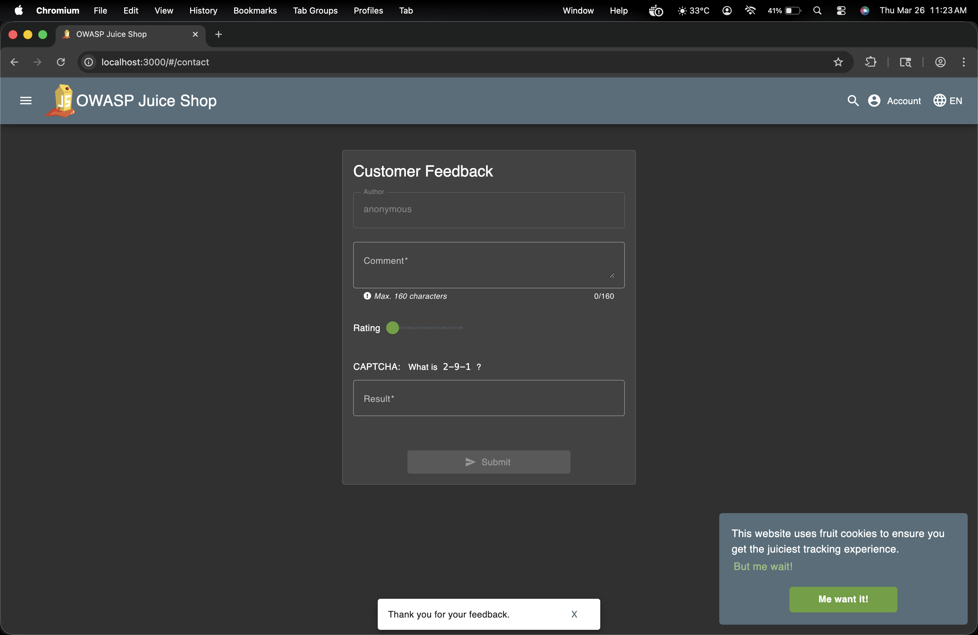
4. If the site is vulnerable, an alert box will pop up.
5. Confirm the XSS attack by checking:
O The browser console (F12> Console).
O The HTTP history tab in Burp Suite.
Inspecting the request and response in Burp Suite.
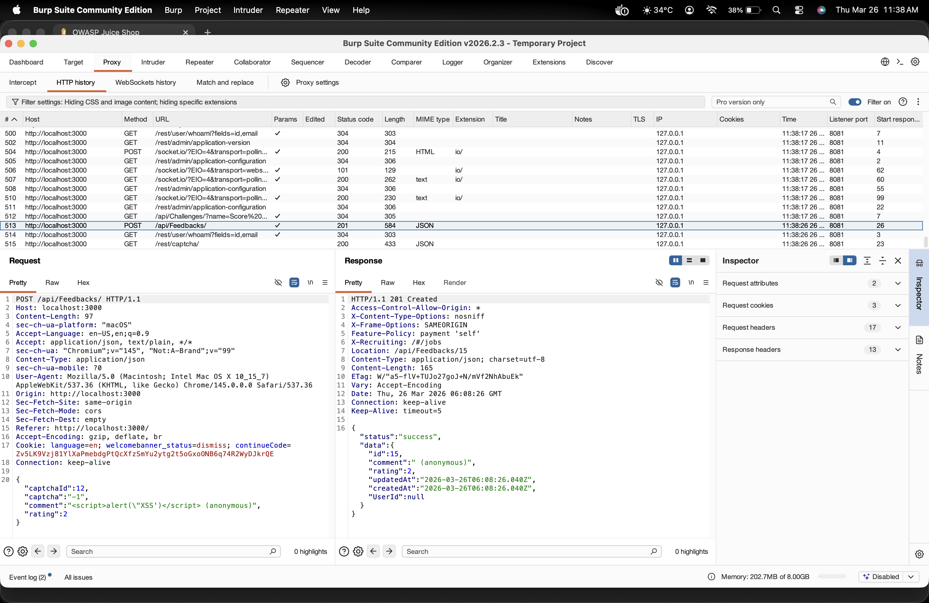
Step 4: Stored XSS Attack
1. Locate a form where the input is stored and displayed later (e.g., user profile, reviews, or
feedback section).
2. Enter the payload:
<script>document.write('<img src=x onerror=alert("Stored XSS")>");</script>

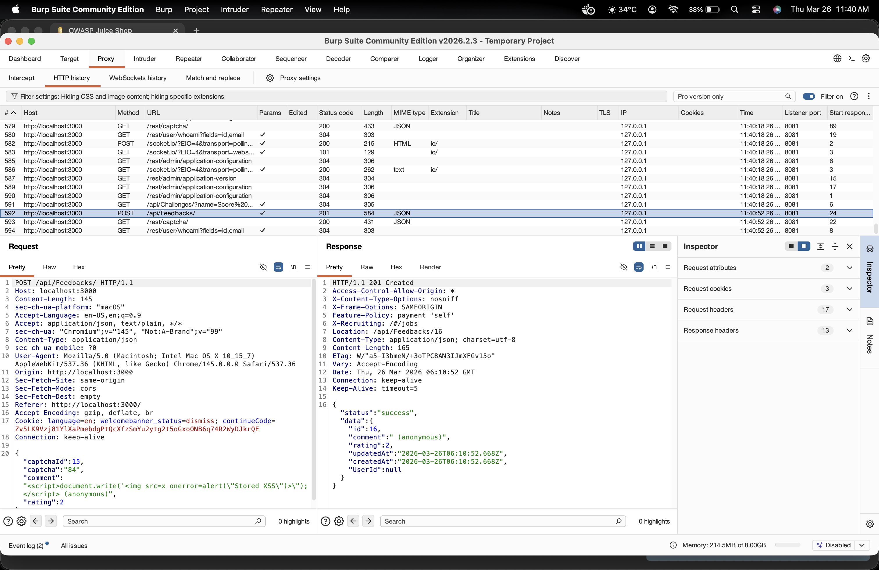
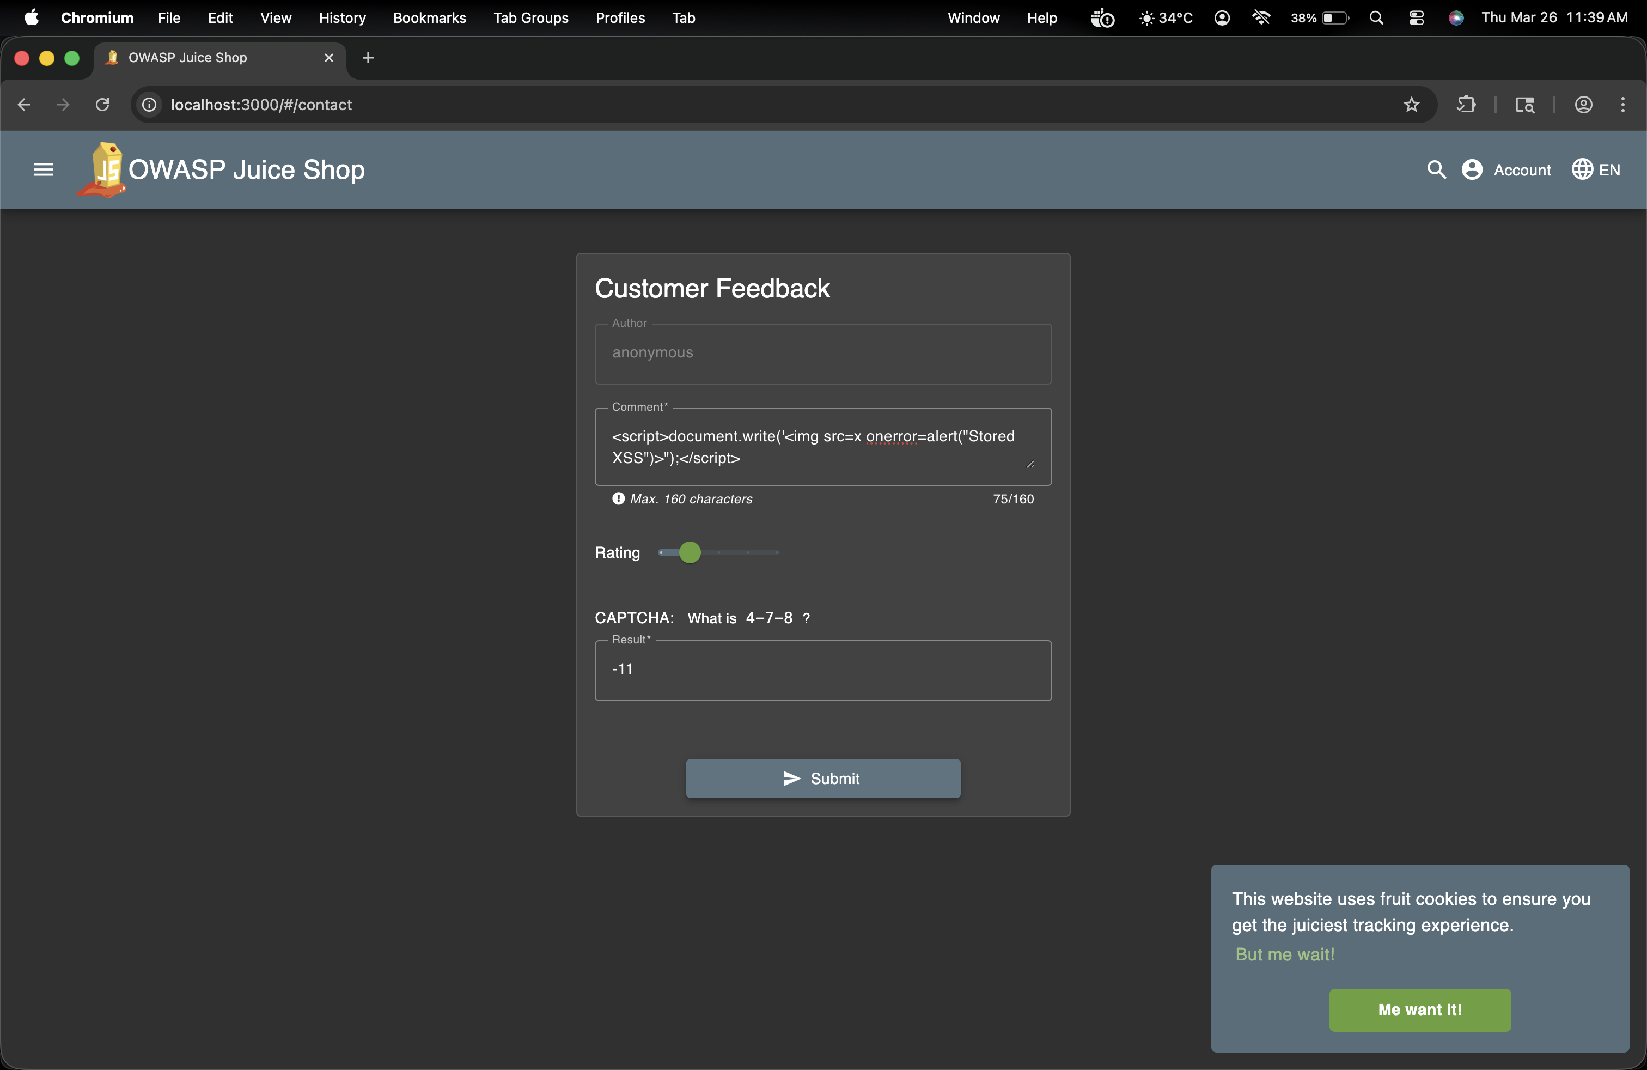
3. Submit the form.
4. Reload the page where the stored input is displayed.

